Qn1. Program1:

#1.Create a null vector of size 10 but the fifth value which is 1.

import numpy as np

null_vector = np.zeros(10)#creating zero vector of size 10

null_vector[4]=1 #changin the 5th value (index 4) to 1

print(null_vector)

Output:

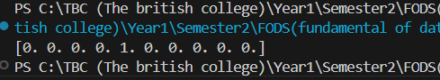

Qn2. Program2:

#2. Ask user to input two numbers a, b.

#Write a program to generate a random array of shape (a, b) and

#print the array and avg of the array

import numpy as np

a = int(input("Enter the row of the array : "))

b = int(input("Enter the column of the array : "))

#generating the random array

rand_array = np.random.randint(0,100, size=(a,b)) #random number from 0-1, array shape user input

print(rand_array)

average = np.mean(rand_array) #for finding the average

print (f"THe average of the array is {average}")

Output:

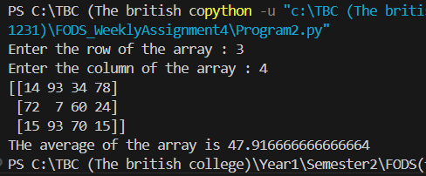

Qn3. Program3:

#3. Create a vector of size 10 with values ranging from 0 to 1, both excluded.

import numpy as np

#vector from 0-1 of size 10

vector = np.linspace (0,1,10)[1:-1] #selects elemts from index one to second last element

print (f"The vector of 0-10 is {vector}")

Output:

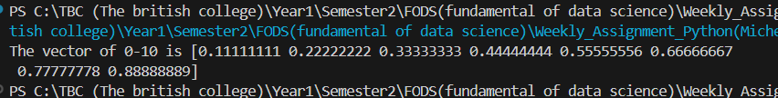

Qn4. Program4:

#4.  Can you create a identity matrix of shape (3,4).

#  If yes write code for it.

import numpy as np

m = np.eye(3,4)

print (f"The identity matrix of shape (3,4) is \n {m}")

Output:

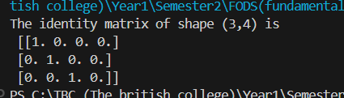

Qn5. Program 5:

#5. Create a 5x5 matrix with row values ranging from 0 to 4

import numpy as np

matrix = np.arange(25).reshape(5,5) #making (5,5) matrix

matrix = matrix % 5 #keeping the remainder in matrix

print (f"The 5x5 matrix 0-4 is \n {matrix}")

Output:

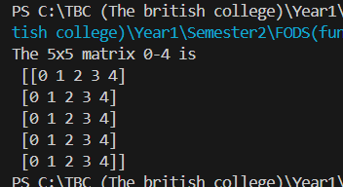

Qn6. Program 6:

#6.Write a program to input an array of numbers from the user (at least 10 elements in list),

# sort them and perform slicing operations to get elements between indexes such as 2-5, 5-8, 2-9.

import numpy as np

number = []

for i in range (0,10) :

  num = int (input(f"Enter the number {i+1} : "))

  number.append(num) #appending the number in empty list

number_array =np.array(number) #converting into array

print (f"Original array: {number_array}")

sort_arr = np.sort(number_array)

print (f"The sorted number: {sort_arr}")

slicing1 = sort_arr[2:6] #displays elements from 2-5 index

slicing2 = sort_arr[5:9]

slicing3 = sort_arr[2:10]

print (f"The elements between 2-5: {slicing1}")

print (f"The elements between 5-8: {slicing2}")

print (f"The elements between 2-9: {slicing3}")

Output:

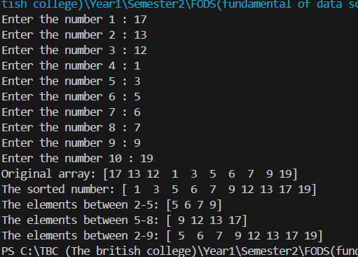

Qn7. Program7:

#7. Create an array of random integer numbers as a numpy array,

#7. Create an array of random integer numbers as a numpy array,

#sort them and perform operations such as reshaping of the array into matrix of feasible dimensions.

#(e.g., if we have an array of 1 * 10, then we can reshape it into 2 * 5 or 5 * 2 matrix.)

#[Hint: Use the array of reshape (row * column)]

import numpy as np

array = np.random.randint(0,100,size=10)

sorted_array=np.sort(array)

matrix_2_5=sorted_array.reshape(2,5)

matrix_5_2=sorted_array.reshape(5,2)

print("original array: ")

print(array)

print("\nsorted array: ")

print(sorted_array )

print("\nreshaed matrix (2x5): ")

print(matrix_2_5)

print("\nreshaped matrix (5x2): ")

print(matrix_5_2)

Output:

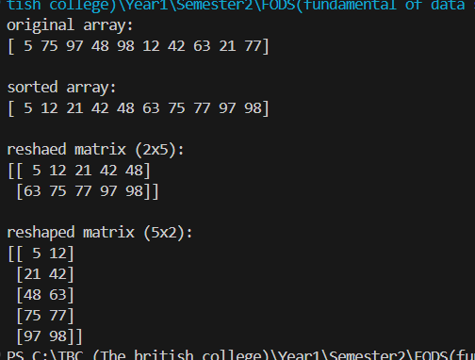

Qn8. Program 8:

#8. Write a Pandas program to add, subtract, multiple and divide two Pandas Series.

import pandas as pd

import numpy as np

a = pd.Series([1,2,3,4,5])

b = pd.Series([6,7,8,9,10])

print (f"The sum is:\n{a+b}\n")

print (f"The subtraction is:\n{a-b} \n")

print (f"The multiple is: \n{a*b} \n")

print (f"The quotient is: \n{a/b}")

Output:

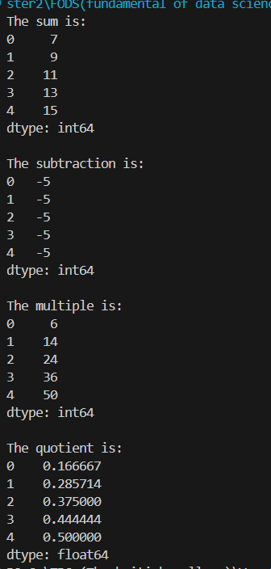

Qn9. Program9:

Output: